**LEARNING GITBASH**

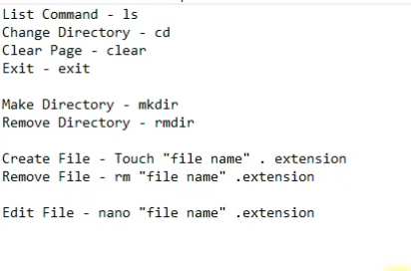

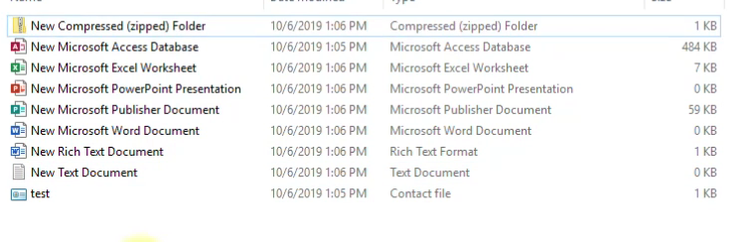

EXTENSIONS – zip, accdb, xlsx, pptx, pub, docx, rtf, txt, pdf, contact, etc.

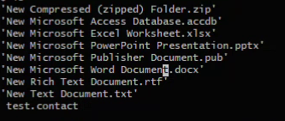

Extention of your choice.

FOR CREATING FILE YOU NEED TO TYPE THIS – touch (name).(extention)